Task 2 | Safe Refactoring – 15 Marks

Before / After Code Excerpts & Refactoring Decisions

1. Eliminating Repetitive Category Branching (Consolidate Duplicate Conditional Fragments)
- Before (legacy_order_system.py):
Python
total = 0
for item in items:
if item['category'] == 'book':
total = total + item['price'] * item['qty']
elif item['category'] == 'electronics':
total = total + item['price'] * item['qty']
else:
total = total + item['price'] * item['qty']
- After (refactored_order_system.py):
Python
def calculate_subtotal(items: List[Dict[str, Any]]) -> float:
"""Calculate the raw subtotal across all items regardless of category."""
validate_items(items)
return sum(item['price'] * item['qty'] for item in items)
- Justification: In the legacy code, every branch ('book', 'electronics', and else) executed the exact same arithmetic (item['price'] * item['qty']). Removing the dead branching logic and extracting a generator expression inside calculate_subtotal() eliminates visual clutter, reduces cyclomatic complexity, and makes it immediately obvious that item categories do not currently alter base pricing.

2. Replacing Magic Numbers with Named Constants
- Before (legacy_order_system.py):
Python
if customer_type == 'student':
total = total - (total * 0.1)
elif customer_type == 'staff':
total = total - (total * 0.05)
if delivery == 'express':
total = total + 250
elif delivery == 'standard':
total = total + 100
- After (refactored_order_system.py):
Python
STUDENT_DISCOUNT_RATE = 0.10
STAFF_DISCOUNT_RATE = 0.05
EXPRESS_DELIVERY_FEE = 250
STANDARD_DELIVERY_FEE = 100
- Justification: Hardcoded literals like 0.1, 0.05, 250, and 100 obscure business intent and risk inconsistencies if referenced in multiple places. Defining module-level named constants (STUDENT_DISCOUNT_RATE, EXPRESS_DELIVERY_FEE, etc.) makes the business rules self-documenting and allows future rate adjustments in a single location without digging through calculation logic.

3. Extracting Single-Responsibility Helper Functions
- Before (legacy_order_system.py): order_total() handled item iteration, subtotal summation, discount calculation, delivery surcharges, and rounding inside a single monolithic function.
- After (refactored_order_system.py):
Python
def order_total(items: List[Dict[str, Any]], customer_type: str, delivery: str) -> float:
subtotal = calculate_subtotal(items)
discount = calculate_discount(subtotal, customer_type)
delivery_fee = calculate_delivery_fee(delivery)

final_total = (subtotal - discount) + delivery_fee
return round(final_total, 2)
- Justification: Decomposing order_total() into calculate_subtotal(), calculate_discount(), and calculate_delivery_fee() enforces the Single Responsibility Principle (SRP). Each step of the pricing pipeline can now be understood, debugged, and unit-tested in isolation while preserving the exact signature and return behaviour of the public order_total() function.

Task 4 | Regression testing and demonstration - 10 marks

Before / After Comparison Table
Using the standard test basket (2x Notebook @ 300 PKR + 1x USB Drive @ 800 PKR = 1400 PKR subtotal):
# | Test Case | Customer Type | Delivery Method | Legacy Total (PKR) | Refactored Total (PKR) | Status
1 | Regular Customer | 'regular' (0%) | 'standard' (+100) | 1500.0 | 1500.0 | Match (Pass)
2 | Student Discount | 'student' (10%) | 'standard' (+100) | 1360.0 | 1360.0 | Match (Pass)
3 | Staff Discount | 'staff' (5%) | 'standard' (+100) | 1430.0 | 1430.0 | Match (Pass)
4 | Standard Delivery (1x Pen @ 100) | 'regular' (0%) | 'standard' (+100) | 200.0 | 200.0 | Match (Pass)
5 | Express Delivery | 'student' (10%) | 'express' (+250) | 1510.0 | 1510.0 | Match (Pass)
6 | Negative Input (price: -300 or qty: -2) | 'regular' / 'student' | 'standard' / 'express' | Silently calculates wrong total | Raises ValueError | Verified (Pass)

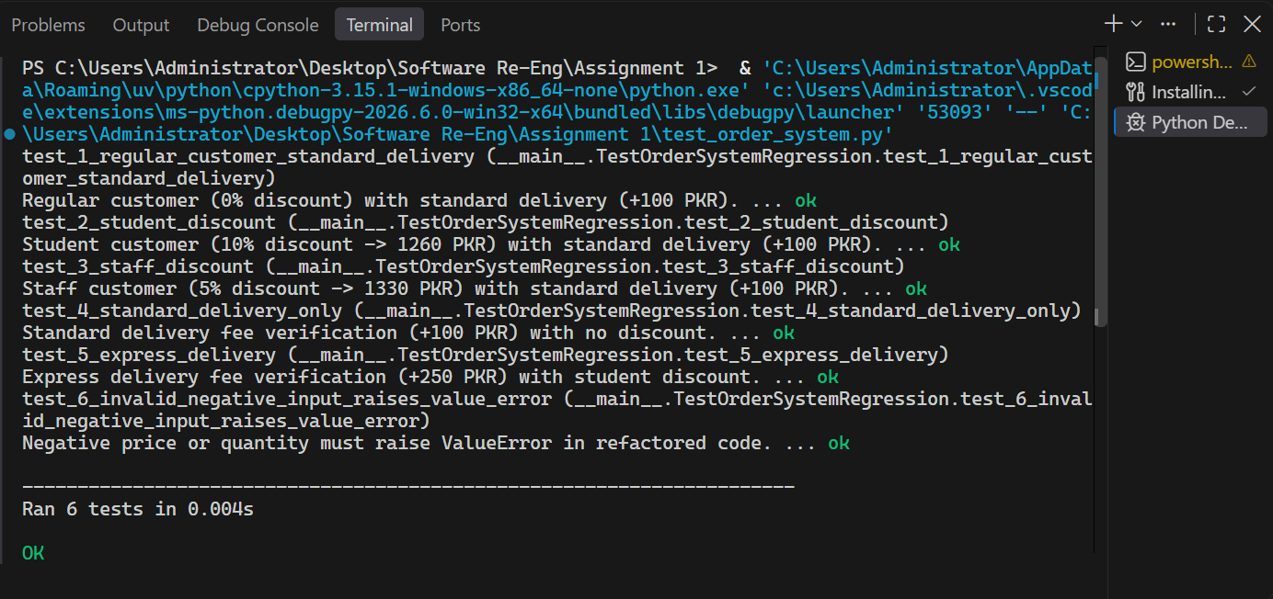

Task 5: Reflection and SPE Classification

SPE Classification and Justification (156 words)
Although the current starter script appears simple enough to behave like an S-type (Specifiable) program with fixed arithmetic rules, a real-world order calculator operating in a business environment is fundamentally an E-type (Evolving) program. This classification assumes the software does not exist in a mathematical vacuum, but rather models commercial operations subject to shifting economic, regulatory, and user demands in Pakistan (PKR). Unlike an S-type program—where the specification is static and provably correct once written—or a P-type program defined by iterative heuristic approximations, an e-commerce checkout system’s validity depends on continuous alignment with the real world.
Under Lehman’s First Law (Continuing Change), the system must continuously adapt to remain satisfactory; for example, the store may need to introduce provincial sales tax (GST) rates by product category, adjust express courier fees due to fuel inflation, or add seasonal promotional codes. Under Lehman’s Second Law (Increasing Complexity), repeatedly patching the legacy order_total function with nested if/elif blocks for category-specific taxes, bulk-buy tiers, and regional delivery zones would rapidly degrade the internal structure—making prior refactoring into modular helper functions essential to prevent architectural decay.

